Cooperating Teacher Account Renewal instructions.

You can use the UF Cooperating Teacher key code to renew your account by following the steps below:

- Go to https://www.watermarkinsights.com/signon
- On the Watermark Sign In page, select the Taskstream tile
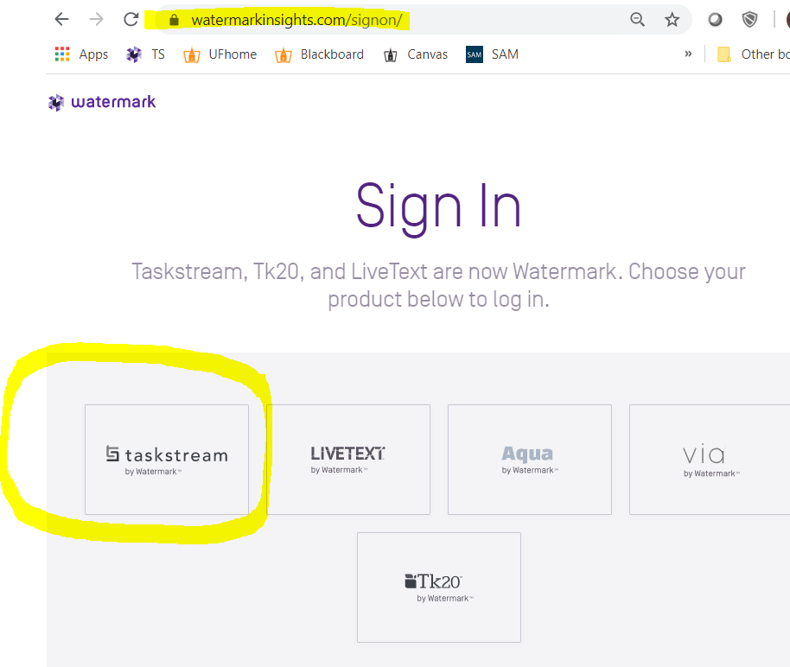

- Choose Create/Renew Account
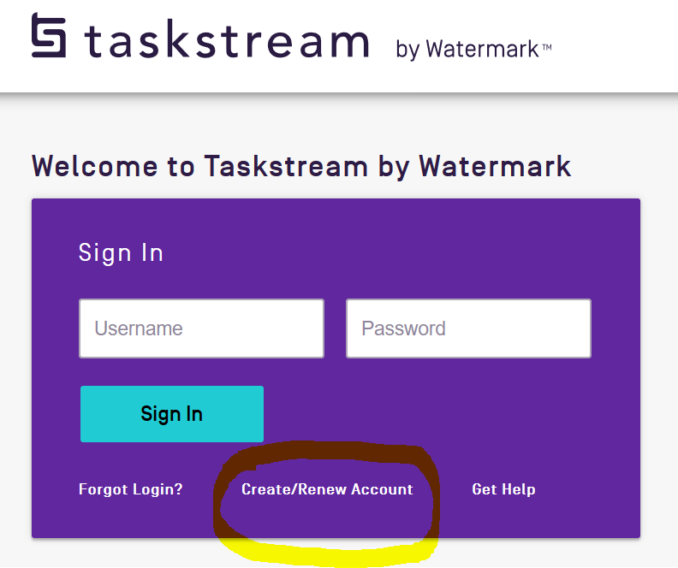

- Select the radio button to “Renew my Taskstream Subscription”
- Enter the key code in the appropriate fields under Option 2 and click the Continue button.
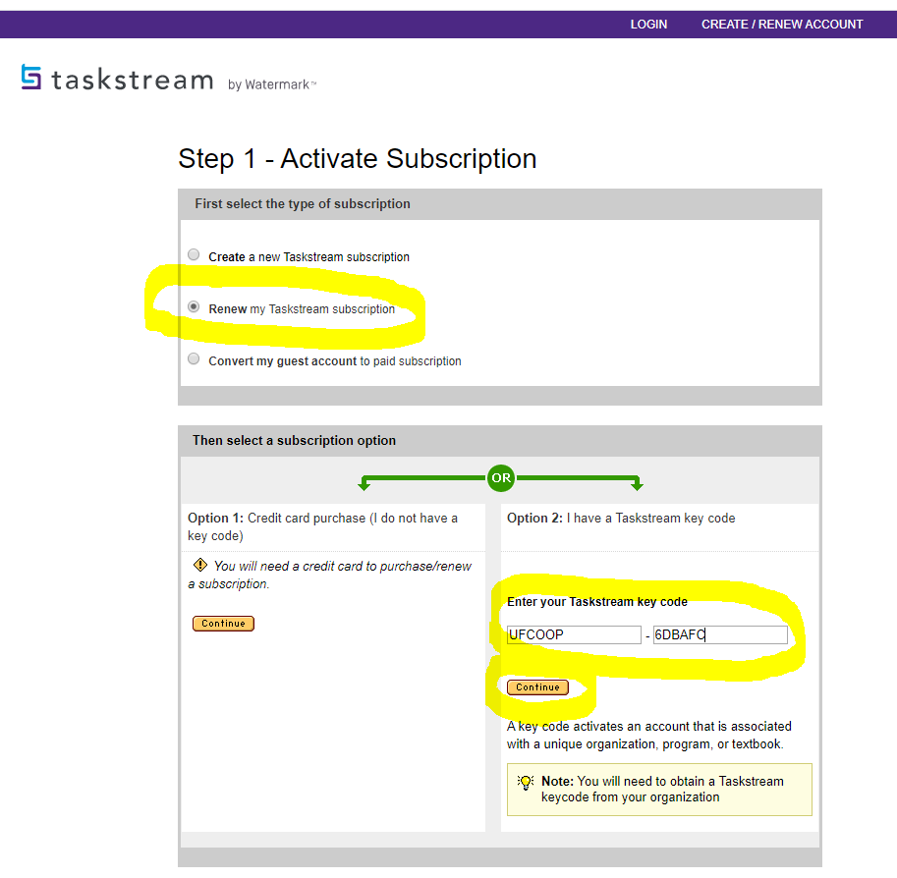
- Use the email account that you used in the past. If you do not recall your password, click the link for a password reset link.
- Confirm your registration information in Step 4. If you need to edit any of the information, click the Edit button. Otherwise click Continue to complete your renewal.

