The University of Findlay
College of Education
Spring 2024
The mission of The University of Findlay is to equip our students for meaningful lives and productive careers.
Course Number/Title: EDUC 771: Research III Dissertation
Credit Hours: 1
Class Time/Place: Asynchronous Canvas Course
Prerequisites and Co-requisites: Co-requisite EDUC 770.
Instructor: Dr. Jennifer Theriault
Instructor Contact Information: jennifer.theriault@findlay.edu
Office Hours: By appointment.
Course Description: This course is the second of three courses to focus on the candidate’s production of a doctoral dissertation. This course will allow the candidate time for regularly scheduled meetings with the dissertation Chair during which they will focus on the development of the dissertation proposal and the related research design. At the conclusion of the course, the candidate will submit their completed dissertation proposal to their dissertation committees for approval.
Course Objectives:
Candidates will:
- Reach out within the first 3 weeks of the semester to schedule at least 2 meetings with the dissertation Chair to discuss dissertation progress and devise a schedule for drafts and feedback.
- Respond to all communication from the dissertation Chair and committee members in a timely and professional manner.
- Provide the dissertation Chair initial draft and revised draft copies of Chapter 3 according to agreed upon schedule.
- Work with dissertation Chair to schedule Dissertation Proposal Defense prior to August 1.
- Provide completed draft of Ch. 3 two weeks prior to the final day of semester classes for feedback from dissertation Chair and committee members.
- Prepare for providing the dissertation Chair and committee members the dissertation proposal draft of Chapters 1-3, all appendices (including email communication, survey instruments, interview protocols, etc), and complete Reference pages at least two weeks prior to scheduled dissertation proposal defense.
Required Textbooks and other materials: There are no required textbooks or materials for this course.
Instructional Strategies:
Case Analysis | X | Library and Internet Research | X
Debate |  | Practice/drill
Discovery/Independent Research | X | Problem solving | X
Discussion/Questioning/Interviewing | X | Reading assignments
Experiential Learning |  | Role playing/simulation games
Field Experience |  | Service Learning
Group Presentation |  | Video/Audio Review and Critique
Laboratory Experiences |  | Other
Lecture

Methods of Assessment:
Abstracts |  | Participation | X
Attendance | X | Peer Evaluation
Capstone Project |  | Portfolio
Case Study |  | Portfolio Lab Performance
Exams |  | Presentations
Group Projects |  | Professional Evaluation
Homework Assignments |  | Quizzes
Internet Research |  | Research project
Journaling |  | Other
Lab Performance
Oral/written review of literature | X

Grading:
- Reach out within the first 3 weeks of the semester to schedule at least 2 meetings with the dissertation Chair to discuss dissertation progress and devise a schedule for drafts and feedback. (50 points)
- Respond to all communication from the dissertation Chair and committee members in a timely and professional manner. (50 points)
- Provide the dissertation Chair initial draft and revised draft copies of Chapter 3 according to agreed upon schedule. (50 points)
- Work with dissertation Chair to schedule the dissertation proposal defense prior to August 1. (25 points)
- Provide completed draft of Ch. 3 two weeks prior to the final day of semester classes for feedback from dissertation Chair and committee members. (50 points)

When agreed upon by dissertation Chair, provide the dissertation Chair and committee members the dissertation proposal draft of Chapters 1-3, all appendices (including email communication, survey instruments, interview protocols, etc), and complete Reference pages at least two weeks prior to the scheduled dissertation proposal defense.

TOTAL: 225 points
Grading Scale/Distribution:

Grade | Points | Grading Scale
A | 4.00 | 93-100
A- | 3.67 | 90-92
B+ | 3.33 | 87-89
B | 3.00 | 83-86
B- | 2.67 | 80-82
C+ | 2.33 | 77-79
C | 2.00 | 73-76
C- | 1.67 | 70-72
D+ | 1.33 | 67-69
D | 1.00 | 63-66
D- | 0.67 | 62-60
F | 0.00 | below 60
U | 0.00

University Honor Code:
Each and every student of the University will adhere to the following Honor Code:

“I will not knowingly engage in any dishonorable behavior, cheat, steal, lie, or commit any act of plagiarism during any academic work, course, or endeavor. If I observe an act which I believe violates the University’s Honor Code, I may, at my discretion, report it to the appropriate personnel.”

Student Acknowledgement of University Honor Code:
“I acknowledge that I have fully complied or will comply with all aspects of the University’s Honor Code in submitting this work.”
Student Rights and Responsibilities Statement, Article VIII-Academic Integrity: http://catalog.findlay.edu/en/current/Undergraduate-Catalog/Student-Rights-and-Responsibilities-Statement/VIII-Academic-Integrity
University Diversity Statement:
As part of our commitment to achieve excellence, the University of Findlay values and actively promotes a welcoming and supportive environment that honors the many aspects of diversity. We aspire to foster acceptance of, respect for, and appreciation of all persons in our campus community. We celebrate our commonalities and unique differences, and we acknowledge that diversity broadens learning, stimulates creativity, promotes the exchange of ideas, and prepares our students for meaningful lives and productive careers.

Course Policies and Practices: Students are expected to attend all meetings required by their dissertation committee chairs.
Final Exam Date: There is no final exam for this class.
Special Services: If you are a student with a disability, it is your responsibility to inform your instructor and register with the Office of Accommodation and Inclusion (oai@findlay.edu) at least one week prior to a needed service so reasonable accommodations can be made.
Course and Instructor Evaluation: Each student is expected to complete the course and instructor evaluation which is sent electronically to the student by the Office of the Registrar. The electronic notification comes in the form of an e-mail from the UF Registrar’s Office with the following subject line: Online survey for the designated course (e.g., BIOL 102).
Last Date of Attendance Policy: A student's last date of attendance is the date he/she last participated in an online discussion, submitted an assignment that can be tracked or corresponded with the instructor. A student logging into the system is no longer an acceptable method of determining last day of attendance according to federal guidelines. If the student attends all classes, the official last date of the class, as determined by the institution, will be used for reporting purposes.
Tentative Course Outline:
Module | Topic | Assignment
Module 1 | Introduction | Reach out within the first 3 weeks of the semester to schedule at least 2 meetings with the dissertation Chair to discuss dissertation progress and devise a schedule for drafts and feedback. (50 points)
Module 2 | Communication | Respond to all communication from the dissertation Chair and committee members in a timely and professional manner. (50 points)
Module 3 | Chapter 3 Drafts | Provide the dissertation Chair initial draft and revised draft copies of Chapter 3 according to agreed upon schedule. (50 points)
Module 4 | Proposal Draft & Defense | Work with dissertation Chair to schedule dissertation proposal defense by August 1. (25 points)  Provide completed draft of Ch. 3 two weeks prior to the final day of semester classes for feedback from dissertation Chair and committee members. (50 points)  Prepare for providing the dissertation Chair and committee members the dissertation proposal draft of Chapters 1-3, all appendices (including email communication, survey instruments, interview protocols, etc), and complete Reference pages at least two weeks prior to scheduled dissertation proposal defense.
**In addition to the course outline and expectations, it is important to note that Dissertation Proposal Defenses must be completed by August 1, 2024 with all modifications made by August 15, 2024.**

Classroom Environment, Language, and Behavior Expectations
In order to promote an inclusive and constructive learning environment, demeaning, marginalizing, and otherwise negative language and behavior will not be tolerated in the classroom. Respect and courtesy toward the instructor, classmates, and classroom guests are expected. Language and behaviors that are disruptive, abusive, or harassing may result in disciplinary action as specified by the Student’s Rights and Responsibilities Statement.
Syllabus Template Approved by Faculty Senate 26 October 2020
Modified 26 October 2020

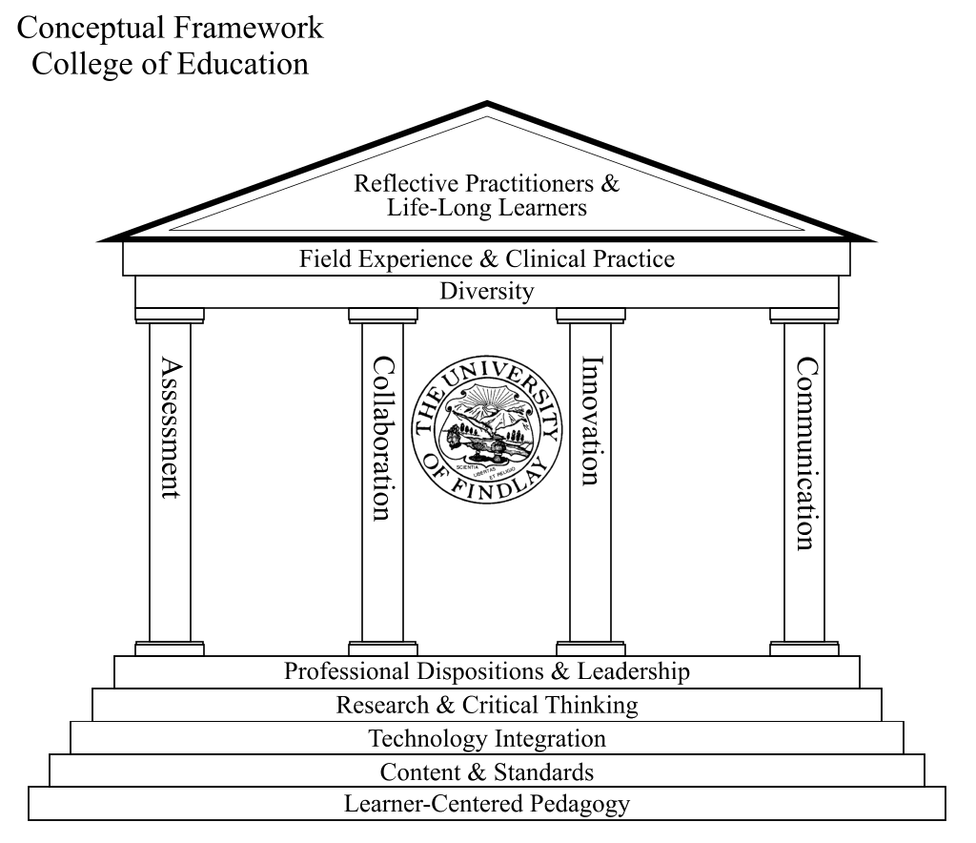
To facilitate the mission of the College of Education, the faculty developed a conceptual framework which reflected the philosophical and pragmatic commitment to experiential-based active learning and meaningful clinical practice with our PK-12 schools/partners. However, due to changes both in the Higher Education and public education systems, the College of Education faculty felt compelled to revisit and refine the original framework to more closely parallel the changing needs of teacher candidates, licensure expectations, professional associations, accrediting bodies and PK-12 public colleagues.
The University of Findlay, College of Education supports continuous, high quality field experience and clinical practice with diversity as the keystone goal. At the foundation, the College of Education faculty model effective teaching through their professionalism, appropriate dispositions and leadership, as well as by engaging teacher candidates in learner-centered pedagogy; utilizing current content and standards (professional and instructional); integrating technology into all content areas; and infusing elements of critical thinking and research (21st Century Skills). The structural pillars mirror what the faculty recognize and embrace as important within the profession of education: appropriate and timely assessment use; collaboration within buildings, classrooms and communities; the use of innovation in all aspects of teaching and learning; as well as effective communication skills which are pivotal for the new generation of teacher candidates and PK-12 students. For the roof of the framework, the teacher candidates as well as the faculty must continually reflect upon their practices and engage in meaningful/collegial discourse, in order to learn and grow in this profession.

COE Mission

The College of Education prepares caring, inclusive, innovative, and highly qualified professionals.
COE Vision
The mission of The College of Education is to prepare caring, competent, reflective and highly qualified professionals through undergraduate and graduate programs that model best practices and lifelong learning. Standards-based programs, reinforced through clinical practice, develop the knowledge, skills and dispositions of successful teachers and reflect a commitment to excellence, scientifically-based research, learner-centered pedagogy, technology integration, innovation, collaboration, outcomes assessment, service learning, and professionalism. The College of Education is committed to continuous improvement through a data-driven, rigorous assessment system so that candidates leaving its programs will be able to synthesize their knowledge, skills, and dispositions to meet standards in innovative ways. The unit’s mission is to encourage candidates to be sensitive and responsive to individual and cultural differences. Thus, they are engaged as change agents in collaboration with their schools and communities and positively impact p-12 student learning.

Philosophy Statement
Faculty in the College of Education at The University of Findlay believe in a constructivist philosophy that lifelong learners and reflective practitioners are developed in institutions wherein:
- Engagement in inquiry, reflection, research, and assessment support the development of caring, competent, and highly qualified candidates;
- Professional programs are consistent with institutional, state and national standards;
- There is synthesis among curriculum, instruction, and clinical practice;
- Commitment to active professional collaboration among regional P-12 communities is implemented at every program level;
- Individual differences and diversity are valued in the development of all effective instruction;
- Emphasis is placed on professional responsibility and accountability as a means of developing lifelong learners and reflective practitioners;
- Technology is an integral part of all programs.

College of Education’s Goals and Objectives
Upon completion of the Undergraduate Teacher Education Program
at The University of Findlay, the Pre-service Teacher will:
- Organize content knowledge for student learning
A.1. Be familiar with relevant aspects of students’ background knowledge and experiences. (OSTP 1.1, 1.2,
1.4, 1.5, 2.5, 4.2, 5.5)
A.2. Articulate clear learning goals for the lesson that are appropriate to the students. (OSTP 1.2, 2.1, 4.1,
4.3, 6.1)
A.3. Demonstrate the understanding of the connections between the content that was learned previously,
the current content, and the content that remains to be learned in the future. (OSTP 2.3, 2.4)
A.4. Create or select teaching methods, learning activities, and instructional materials or other resources
that are appropriate to the students and that are aligned with the goals of the lesson. (OSTP 1.2, 1.5,
2.1, 4.1, 4.2, 4.5, 4.7, 5.4, 5.5)
A.5. Create or select evaluation strategies that are appropriate for the students and that
are aligned with the goals of the lesson. (OSTP 3.1, 3.2, 3.5)
Disposition: Organized: Works in systematic or efficient ways to meet the needs of all students.
(INTASC 1, 2, 3, 4, 5, 6, 7, 8) (OSTP 1.2, 4.4)
B. Create an environment for student learning
B.1. Create a climate that promotes fairness. (OSTP 1.4, 4.5, 5.1)
B.2. Establish and maintain rapport with students. (OSTP 1.4, 5.2)
B.3. Communicate challenging learning expectations to each student. (OSTP 1.5, 4.3, 4.5, 4.6, 6.1)
B.4. Establish and maintain consistent standards of classroom behavior. (OSTP 5.1, 5.5)
B.5. Make the physical environment as safe and conducive to learning as possible. (OSTP 5.2, 5.5)
Disposition: Learner-Centered: Focuses on student well being and learning. (INTASC 1, 2, 3, 4, 5, 6, 7)
(OSTP 5.1, 5.2, 5.4, 5.5)
- Teach for student learning
C.1. Make learning goals and instructional procedures clear to students. (OSTP 2.2, 4.3, 6.1)
C.2. Make content comprehensible to students. (OSTP 1.2, 2.2, 3.5, 4.4, 4.5)
C.3. Encourage students to extend their thinking. (OSTP 1.3, 4.6)
C.4. Monitor students’ understanding of content through a variety of means, provide feedback to students
to assist learning, and adjust learning activities as the situation demands. (OSTP 2.2, 3.3, 3.4, 4.4,
5.3, 5.4)
C.5. Use instructional time effectively. (OSTP 5.3)
Disposition: Reflective: Reviews previous actions, events, or results to make decisions. (INTASC 9)
- Exhibit professionalism as a teacher.
D.1. Reflect on the extent to which the learning goals were met. (OSTP 3.3)
D.2. Demonstrate a sense of efficacy. (OSTP 1.3, 7.1)
D.3. Build professional relationships with colleagues to share teaching insights and to coordinate learning
activities for students. (OSTP 6.3, 6.4, 7.1, 7.2, 7.3)
D.4 . Communicate with parents or guardians about student learning. (OSTP 3.4, 6.2)
Disposition: Lifelong Learner: Grows in professional and pedagogical knowledge. (OSTP 7.1, 7.2, 7.3)
5. Additional COE Objectives
1. Candidates will utilize technology for professional management and teaching strategies. (OSTP 4.2, 4.7,
5.3, 6.1)
2. Candidates will apply their knowledge of research in planning for the diverse needs of children. (OSTP
1.1, 1.2, 3.3, 4.4, 4.5, 4.6, 5.1, 5.2)
3. Candidates will foster relationships with students, colleagues, parents, and the larger community to
assure student learning. (OSTP 3.4, 3.5, 6.1, 6.2, 6.3, 6.4, 7.1, 7.2, 7.3)
4. Candidates will use appropriate standards in planning for students (OSTP 2.3, 4.1)
Disposition: Innovative: Takes new or original approaches to foster student learning. (INTASC 3, 5, 6, 8)
EDUC 771: Research III Dissertation
 | No Points  (0) | Range of Points  (25-49) | Full Points  (50)
Assignment 1: Reach out to dissertation Chair within the first 3 weeks of semester to schedule at least 2 meetings (discuss dissertation progress; devise schedule for Ch. 3 drafts & feedback.  (50 points) | Did not initiate communication with Chair within first 3 weeks of semester; Did not respond to Chair’s request(s) to meet & create schedule; or scheduled but did not attend any meetings. | Did not initiate communication with Chair within first 3 weeks of semester; Did respond to Chair’s request to meet & create schedule; Attended 1 or 2 scheduled meetings. | Did initiate communication with Chair within first 3 weeks of semester; Attended 2 scheduled meetings.
Assignment 2: Respond to all communication from dissertation Chair in a timely & professional manner. (50 points) | Did not respond to any communication in a timely (within an agreed upon timeframe &/or within 72 hours) or provided an extremely delayed response(s); response(s) not professional. | Responded to all or most communication but not in a timely (within an agreed upon timeframe &/or within 72 hours) manner; but did respond in a professional manner. | Responded to all communication in a timely (within an agreed upon timeframe &/or within 72 hours) and professional manner.
Assignment 3: Adhere to agreed upon schedule with dissertation Chair for Ch. 3 drafts & feedback. (50 points) | Did not adhere to agreed upon schedule for drafts & feedback. | Mostly adhered to agreed upon schedule for drafts & feedback. | Adhered to agreed upon schedule for drafts & feedback.
Assignment 4: Work with dissertation Chair to schedule dissertation proposal defense prior to August 1. (25 points) | Did not communicate with dissertation Chair about progress and/or potential dissertation proposal defense date by the end of semester. | Communicated with dissertation Chair about progress and potential dissertation proposal defense date by the end of semester. | Communicated regularly with dissertation Chair about progress and potential dissertation proposal defense date throughout semester.
Assignment 5: Provide dissertation Chair and committee members completed Ch. 3 draft for review at least 2 weeks prior to the final day of semester classes. (50 points) | Did not share completed Ch. 3 draft for feedback prior to final day of semester classes. | Shared completed Ch. 3 draft for feedback less than 2 weeks prior to final day of semester classes. | Shared completed Ch. 3 draft for feedback at least 2 weeks prior to final day of semester classes.

