

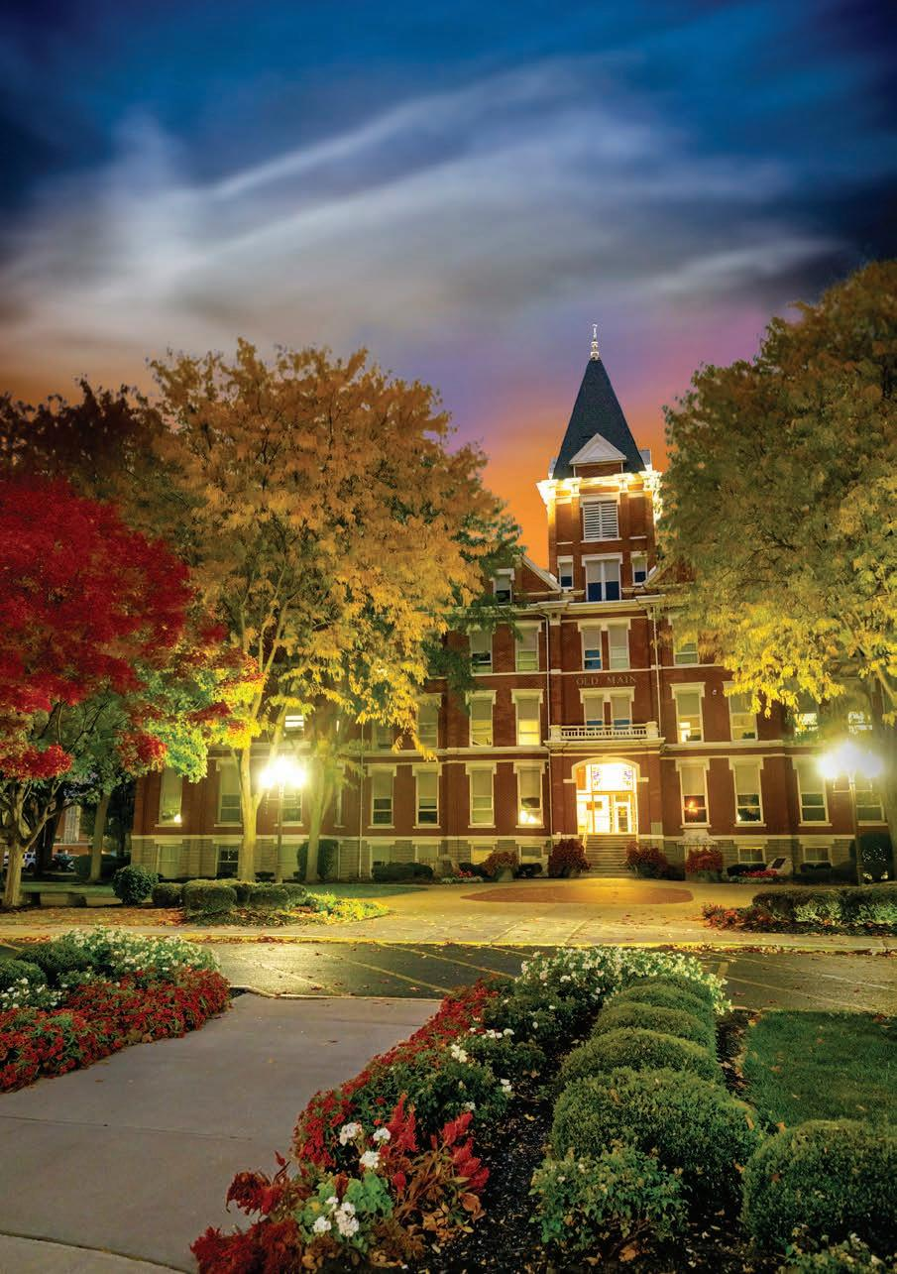

Vice President of Finance

2026 SEARCH
PROSPECTUS

OUR MISSION AND YOUR OPPORTUNITY

To Equip Students for Meaningful Lives and Productive Careers

The University of Findlay, in Findlay, Ohio, announces a national search for a strategic financial leader to serve as the University’s next Vice President of Finance, Treasurer.

Under the leadership of our new president, Richard Ludwick, J.D., D.Ed., the University is posted to embark on the process of creating its next strategic vision. The Vice President of Finance, Treasurer, will play a pivotal role in developing and realizing that future.

Are you interested in helping to shape the University’s next strategic plan and impact the lives of the next generation of Oilers?

Would you like to guide our institution through implementation of an innovative budget model to ensure financial resources continue to support student success and institutional excellence?

Are you ready to partner with the President and Board of Trustees to identify future growth opportunities?

Could you see yourself leading major capital and operational investments that strengthen the University for the future?

The successful candidate will bring strong financial management experience, a proven ability to lead Responsibility Center Management budget implementation, and a collaborative leadership style. The vice president reports directly to the president and serves on the University’s senior leadership team.

For a strategic leader seeking to influence the future of a vibrant and financially sound institution, this position offers both challenge and extraordinary opportunity.

Join a university with strong momentum, dynamic academic
and student programs, an entrepreneurial culture, and
a strong sense of campus community!

OUR HISTORY, OUR FUTURE


Findlay College was founded in 1882 by the City of Findlay and the Churches of God, General Conference. The institution changed its name to the University of Findlay in 1989 to reflect its growth in enrollment and the breadth and diversity of its academic offerings, including newly instituted graduate programs.

The University of Findlay believes in cultivating the potential within each student through academic excellence, transformative experiences, and a supportive community grounded in Christian faith.

UF offers 86 baccalaureate, 10 master’s, and five doctoral degrees, and five doctoral degrees. The University is known for excellence in its Science, Health Professions, Animal Science, and Equestrian Studies programs, but also for cultivating the next generation of business leaders, educators, and innovative thinkers through a dedication to experiential learning and service learning, both in and outside of the classroom.

The University has 30,000 living alumni in 75 countries around the world. The successes of our many alumni in meaningful lives and productive careers are a tribute to UF’s commitment to academic excellence, which is demonstrated by many accolades, including three top rankings:

• Listed by U.S. News & World Report as one of “America’s Best Colleges” for 20 consecutive years.

• Named to Money magazine’s “Best Colleges in the United States” based on quality, affordability, and student outcomes.

• Listed among the “Best Midwestern Colleges” by the Princeton Review.

Learning permeates the campus culture, and the University’s 213 full-time and 198 part-time faculty members embrace a commitment to personalized teaching. The student-to-faculty ratio is 13:1. Many alumni cite close relationships with faculty members as hallmarks of their educational experience at Findlay.

More than 3,200 students are enrolled at UF and about 90 percent of first-year students live in University housing. The diverse student population is highly engaged in the life of the University, participating in over 90 organizations, including special interest clubs, student media, student government, performing arts groups, service clubs, Campus Ministries, academic honorary societies, and Greek life.

Reaching out to the upcoming generation, UF’s College Credit Plus (CCP)
program serves 2,114 high school students. Findlay is the largest private provider of CCP in the state of Ohio and the only 4-year institution in the state to be accredited by the National Alliance of Concurrent Enrollment Partnerships (NACEP). Students can attend classes on-campus, online, or in their home high school where they are taught by credentialed and UF-trained instructors.


The fine arts flourish on campus through a variety of theatre productions, art exhibits, and vocal and instrumental music concerts that offer creative outlets and training for students, while serving as a source of cultural enrichment for the community.

The Findlay Oilers participate in 22 NCAA Division II intercollegiate men’s and women’s sports, as a member of the Great Midwest Athletic Conference (G-MAC). Last year, five teams were conference champions, and 13 teams earned trips to the NCAA postseason. Additionally, our student-athletes continue to excel in the classroom and graduate at a 15 percent higher rate than the national average. In 2024-25, UF was ranked No. 4 in the nation for the most athletes with a 3.5 GPA or better.

The English and Western equestrian teams are members of the Intercollegiate Horse Show Association and have won a lion’s share of national championship titles between them. The English and Western farms at UF are jewels of our campus. With daily instructor-led riding classes, an exceptional school herd, and nationally and internationally renowned instructors, UF Equestrian Studies Programs have set the highest standard in the equestrian world for decades.

UF’s beautiful main campus facilities, on 86 acres, include academic, administrative, and athletic buildings along with eight residence halls, 19 townhouse units, and 21 cottages, as well as faculty and staff offices.

The newest building on campus is the Watterson Center. Along with business classrooms and faculty offices, it houses the bookstore and a large food court. In 2024, the Dick Strahm Champions Field turf project was unveiled. This 83,000-square-foot, high-quality artificial turf system benefits Oiler teams and helps to recruit talented student-athletes.

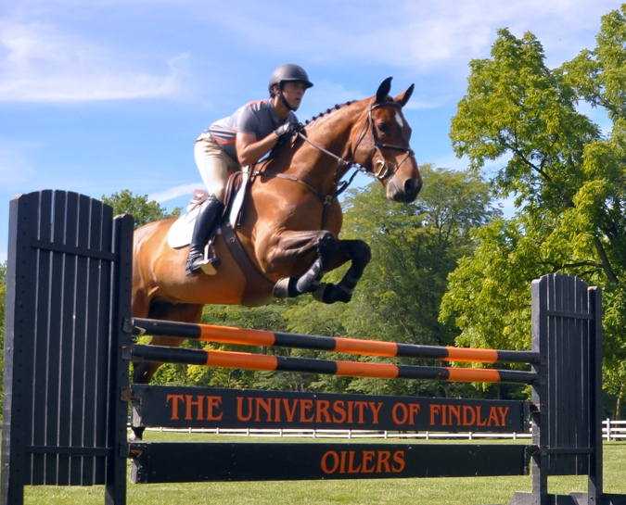
The University also operates a 52-acre facility on the east side of town, the James L. Child Jr. Equestrian Complex, containing the English equestrian studies program. South of town is a University-owned 153-acre farm housing the Western riding and pre-veterinary medicine programs. That complex includes the Dr. C. Richard Beckett Animal Science Building, an impressive $3.7 million facility for UF’s premier animal science programs. In addition, the 54-acre Rieck Center for Habitat Studies serves as a biology field station and is located just a short drive from the main campus.

The five-acre All Hazards Training Center offers hands-on simulations for students, industry, and government agencies involving emergency planning and response. The center provides health and safety training in all 50 states to keep people and the environment safe.

Another jewel of the UF campus is the Mazza Museum, which is home to nearly 22,000 pieces of original artwork. It is the first and largest collection of picture book art in the world with a mission to promote literacy and enrich the lives of all people through the art of picture books. In 2021, the Joseph & Judith Conda STEAM Education Center opened as a 4,000-square-foot addition to the museum, blending art and science activities, and drawing thousands of area schoolchildren and families to campus year-around.

The greater Findlay region is an ideal place to live and work. It is situated approximately 40 miles south of Toledo and 90 miles from Columbus, Dayton and Detroit. Located in Hancock County, Findlay is a family-friendly city close to major metropolitan centers and airports, restaurants, parks, events and entertainment.

Among the highlights of the region:
1) High salary-to-cost-of-living ratio
2) No. 1 Micropolitan in the U.S. based on 543 statistical areas
3) A community of higher education, health care, business, retail and agriculture
4) Ten public school districts in Hancock County, including Findlay City Schools and private school options
5) Major employers include the Fortune 500 Marathon Petroleum Corp., Cooper Tire & Rubber/Goodyear, Whirlpool Corp., and Ball Corp.
6) International businesses and distribution centers with enterprises from nine different countries

LEADERSHIP AGENDA FOR THE VICE PRESIDENT
OF FINANCE, TREASURER

The University of Findlay has long been recognized for developing graduates who lead lives of purpose and impact. The next Vice President for Finance, Treasurer will play a crucial role in ensuring that mission continues to flourish.

The University maintains a solid financial position with a strong balance
sheet, growing net assets, and consistently clean audits. Its annual operating
budget is $82.4 million, supported by investments exceeding $81 million that
reinforce long-term stability and enable strategic priorities, one of which is the
expectation to advance the University to a hybrid Responsibility Center
Management (RCM) model in the upcoming academic year.

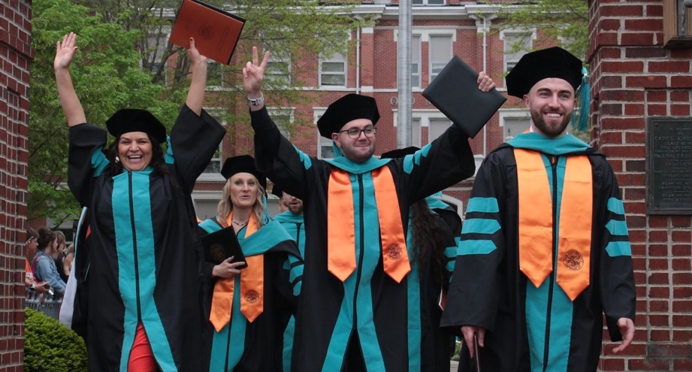
UF just concluded “Together We Will,” its largest comprehensive
campaign in history, setting a new record for philanthropy on campus by reaching $94.8 million, far exceeding our $75 million goal for crucial projects that will transform student support, programs, and facilities.

The vice president, reporting directly to the president, is the primary steward of Findlay’s financial and physical resources. Working closely with the president and cabinet, the vice president plays a central role in major initiatives. The portfolio includes finance, endowment management, and sponsored programs. The vice president will also serve as an active, collaborative member of the senior leadership team.
The vice president will provide leadership and vision for sound fiscal strategies that sustain the University’s financial strength and support its future growth. Responsibilities include short- and long-term financial planning and analysis, budget modeling, facilities planning, risk management, and investment oversight.

The vice president serves as the primary liaison to Board of Trustees committees on business affairs, investments, and audit. The vice president also represents the University’s interests with external constituents, particularly in the Findlay area.

Maintain Efficient, Cost-Effective Operation of UF
The vice president will review business operations and systems to improve efficiency, effectiveness, and the use of technology. The vice president will also ensure that the University’s policies support fair and efficient operations.

Refine the Budget Process and Develop a Budget Model
The vice president will develop a budget model that supports scenario planning and forecasts short- and long-term financial outcomes. Working with the president and cabinet, the vice president will integrate this model into a revised budget process that promotes transparent information sharing and links strategic priorities to financial results.

Provide Leadership to the Business Affairs Division
The vice president must have excellent management skills to lead in the business affairs division – mentoring and developing the staff, inspiring them to do their best work, and ensuring they continue as a high performing team. The vice president needs to have a collegial style and communicate effectively with the staff.

Gain Trust and Communicate Effectively with the Campus About Financial Issues
The vice president must be able to gain the trust of the campus and communicate clearly and effectively with all constituencies about finance and facility issues.

Leadership Qualities and Qualifications
The successful candidate will demonstrate unquestioned integrity, communicate exceptionally well, and build trust through strong interpersonal skills and collaboration. The next vice president will be a highly effective financial leader with strong analytical and management abilities, as well as experience with financial management systems.

The successful candidate will be entrepreneurial in spirit, willing to think creatively, and take prudent risks. They will have an appreciation for the University’s close ties to its region coupled with experience creating partnerships with businesses and/or non-profit organizations.
The vice president will be well versed in higher education finance and knowledgeable about critical areas in the portfolio and have a significant and progressive record of sustained leadership experience in a supervisory role within business affairs.

Experience in business, non-profits, or other sectors as well as experience in higher education will be given consideration. A bachelor’s degree is required, and a CPA, MBA, or other advanced degree is preferred.

Application Process
Applications can be completed at Workday Application Link

Applications must include a cover letter that addresses the priorities and qualifications described in this search prospectus; a curriculum vitae; and a list of at least three professional references with contact information, including telephone and email, and a note indicating the candidate’s working relationship with each. References will not be contacted without the explicit permission of the candidate.
This position is open until filled.

The University of Findlay is an Equal Opportunity Educator and Employer. It is the university’s policy to prohibit discrimination and provide equal opportunity to all employees and applicants for employment, without regard to their race, sex (including gender identity/expression), color, religion, ancestry, national origin, age, disability, veteran status, military, or sexual orientation.

1000 N. Main Street, Findlay, OH 45840 • www.findlay.edu

