Requirements for Digitally Accessible PDF Files for OhioLINK ETD Center Submission 2023

Purpose & Policy
The University of Findlay is committed to ensuring equal access to university programs and services for individuals with disabilities in accordance with the Americans with Disabilities Act of 1990 (ADA), the ADA Amendments Act of 2008, and Section 504 of the 1973 Rehabilitation Act as amended. Equal access includes access to digital documents created by University programs.

Beginning January 31, 2023, the University will require that all theses and dissertations submitted to the OhioLINK Electronic Theses and Dissertations Center (ETD) meet the OhioLINK minimum requirements for digitally accessible PDF files. This document provides an overview to assist students in ensuring their submissions meet these requirements.

OhioLINK ETD Center’s Recommended Minimum Requirements for ETD PDFs
- PDF file includes full text, not images of text
- PDF accessibility permission flag is checked
- Text language of the PDF is specified
- Figures and images include alternative text
- PDF includes a title

How to Make Your Final PDF Document Accessible

Start with an Accessible Word Document
Making your original source document as accessible as possible will help to create an accessible PDF document. We recommend that students use Microsoft Word since it’s a standard word processor and has a built in accessibility checker. We show you first how to meet three of the minimum requirements using options within your Word document that will convert over to your PDF. We then provide additional best practices for creating an accessible document.

Minimum requirements

Text Language is specified
It’s important to indicate the language of your document for a screen reader to read it properly. It may be set to English by default. To check the setting within your Word document, click on Review, then Language.

Figures and images include alternative text
Alt text describes an image or figure to a screen reader user. Select your image, right click, and click View Alt Text. See Microsoft’s overview on writing informative alt text.
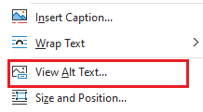

Includes a title
A document’s title is part of its overall metadata which carries over to a PDF. This is found in the documents properties along with author information. Click File, then Info, and add title information.
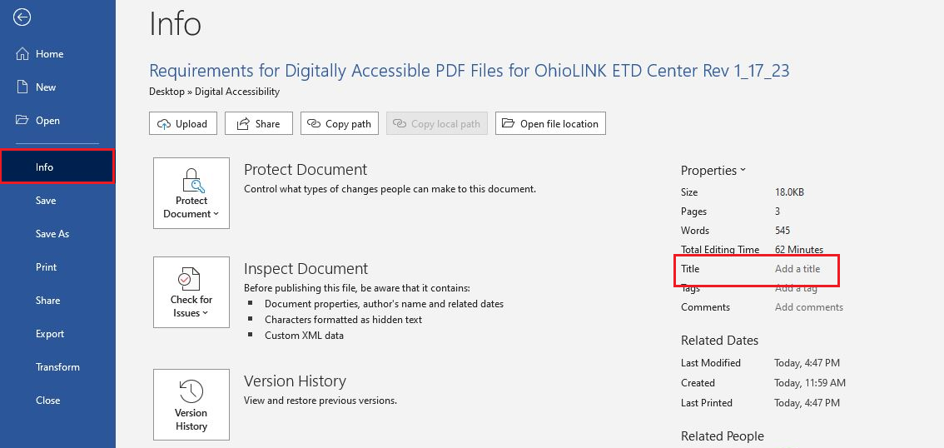

Additional Best Practices for Creating Accessible Documents
For complete details and information, refer to the Microsoft Accessibility Guide.
- Use the built in headings and styles options for Word.
  - Headings and other built-in styles provide structure and organization to your document, telling users what the major sections and subsections are. This is important for screen readers too. Use Title for your title, then Headings in logical order- Heading 1, Heading 2, etc.
- Avoid using tables if you can.
  - Tables can make screen readers lose track of their locations. If you cannot avoid tables, please follow Microsoft’s guidelines on formatting them properly.
- Use sufficient contrast for text font and background colors.

Use Microsoft Word’s Built-in Accessibility Checker
Use the accessibility checker periodically as you write to help you avoid accessibility mistakes. Click on Review, in the toolbar, then Check Accessibility.
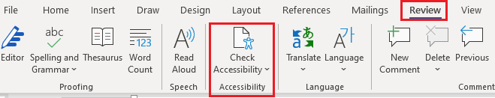

Converting the Document to a PDF

Saving your document as an accessible PDF
- If using Microsoft Word, use Save As, and choose PDF. Select Options.
- Make sure the Document Structure Tags for Accessibility checkbox is selected.
- Also, check the Create Bookmarks Using Headings box.
