Cap and Gown Order Form – Spring 2024
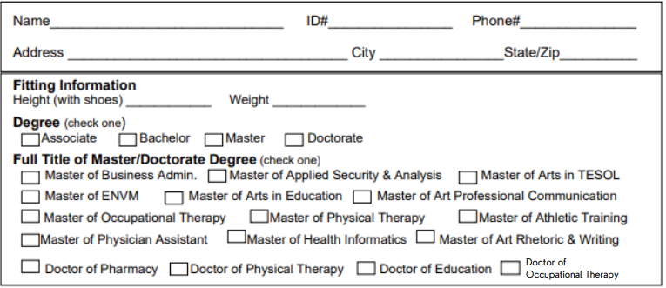Shipping (check one)
Items Ordered (Tax Not Included)
Undergrad
Full Bachelor Unit (Basic plus stole) $100 Basic Bachelor Unit (cap, gown, tassel) $70
Gown $45 Tassel $20 Cap $10 Stole of Gratitude $35
Graduate
Full Master Unit (Basic plus stole) $140 Basic Master Unit (cap, gown, tassel, hood) $110
Gown $65 Hood $40 Tassel $20 Cap $10 Stole of Gratitude $35
Doctorate
Full Doctorate Unit (Basic plus stole) $180 Basic Doctorate Unit (tam, gown, tassel, hood) $150
Gown $90 Hood $50 Tassel $20 Cap $10 Stole of Gratitude $35
I will be picking up my Regalia Please ship my Regalia $15 per unit (4/1/2024 last day for shipping.

Send your order to Email: SM8491@bncollege.com Pick Up: Regalia may be UF Bookstore picked up in AMU during Senior Salute
301 Davis St.
Findlay OH 45840

